Name: Jamaica Rose T. Fabon Date: April 16, 2025
Year & Section: BSIT 3A

BeeHive Restobar Monitoring and Ordering System
Brief System Description
The BeeHive Restobar Monitoring and Ozrdering System is a web-based platform designed to streamline restaurant operations and improve customer experience. It allows customers to conveniently browse the menu, place orders, and track their order status in real time. The system also supports both cash and online payment methods, making transactions flexible and efficient.
On the administrative side, the system enables staff to manage menu items, update store availability, monitor incoming orders, and track daily sales. This centralized system improves coordination between customers and staff, reduces manual errors, and enhances overall service efficiency.
2. Actors / Users
The system has two main actors:
- Customer
- Interacts with the system to order food and check status.
- Admin
- Personnel responsible for managing operations and monitoring system activities.

- Staff
- Manage active customer orders
3. Main System Functions
Customer Functions
- View Store Status
- View Menu
- Add Items to Order
- Place Order
- View Order Status
- Make Cash or Online Payment

Admin/Staff Functions
- Log In
- Set Store Status (e.g., open/closed)
- Manage Menu (add/edit/delete items)
- View Orders
- Update Order Status
- Monitor Daily Sales

UML DIAGRAM (Use Case)
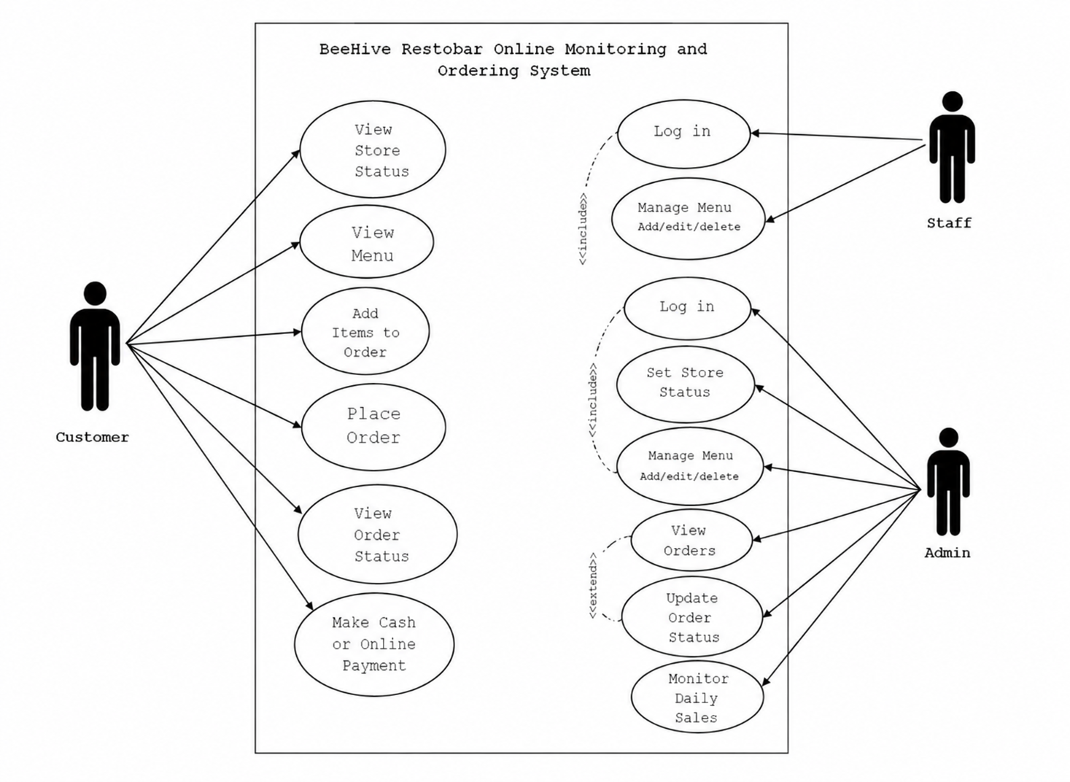
Manage /View/ Update Orders
Monitor
Sales

